**CPU Scheduling**

**Submission:**

* Deadline: Wednesday, October 11, 2023, 8:00 pm HKT.
* Answer ALL questions. Add additional pages if necessary.
* Submit this answer sheet via Canvas->Assignments->Tutorials->Tutorial 4.

**Questions**

1. Compute the response time and turnaround time when running three jobs of length 200 with the SJF (./scheduler.py -p SJF -l 200,200,200) and FIFO (./scheduler.py -p FIFO -l 200,200,200) schedulers.

**Answer:**

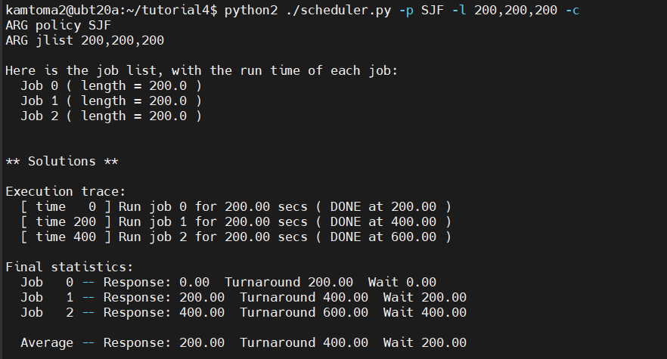

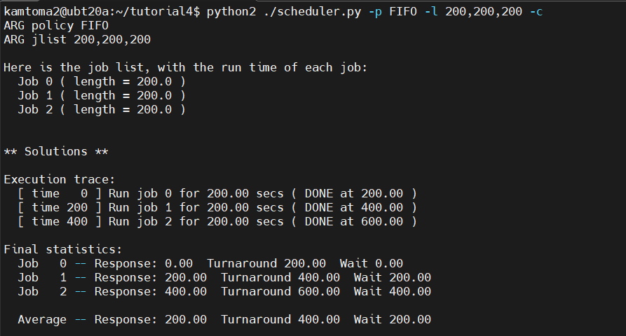

1. Now do the same but with jobs of different lengths: 100, 200, and 300. The commands are (./scheduler.py -p SJF -l 100,200,300) and (./scheduler.py -p FIFO -l 100,200,300). What if you change the order of the job length? Try different orders to find the difference.

**Answer:** 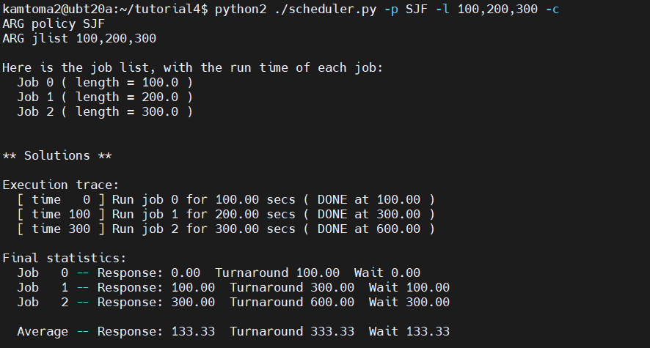

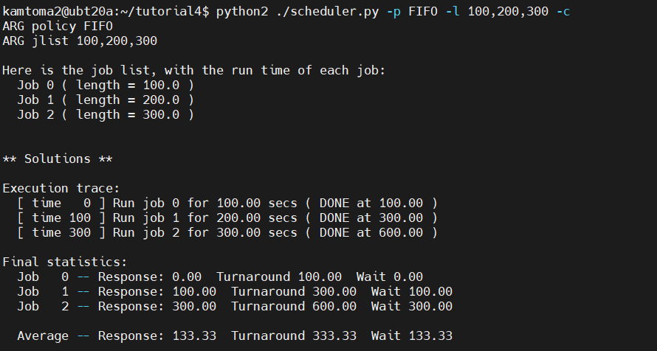

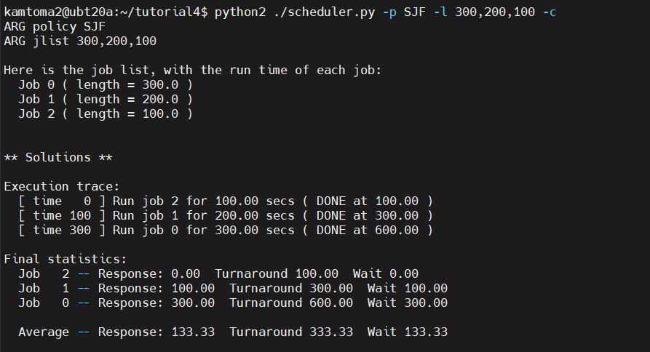

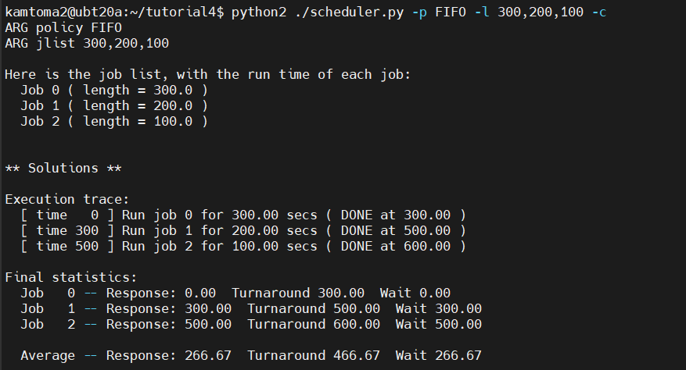

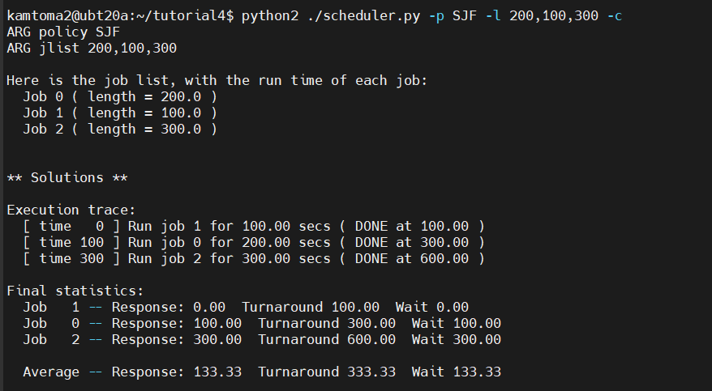

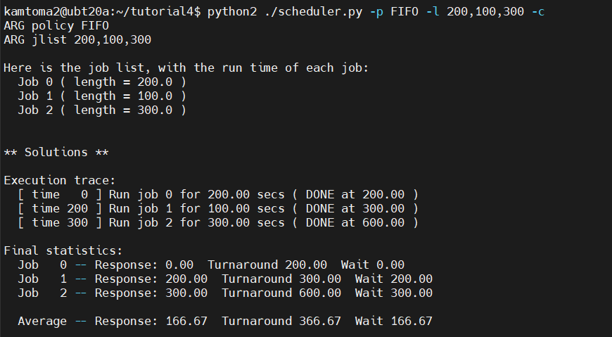

1. Compute the response time and turnaround time when running three jobs of length 3 with the RR scheduler and a time-slice of 1 (./scheduler.py -p RR -l 3,3,3 -q 1). Do the same but change the job lengths as 3,2,4.

**Answer:** 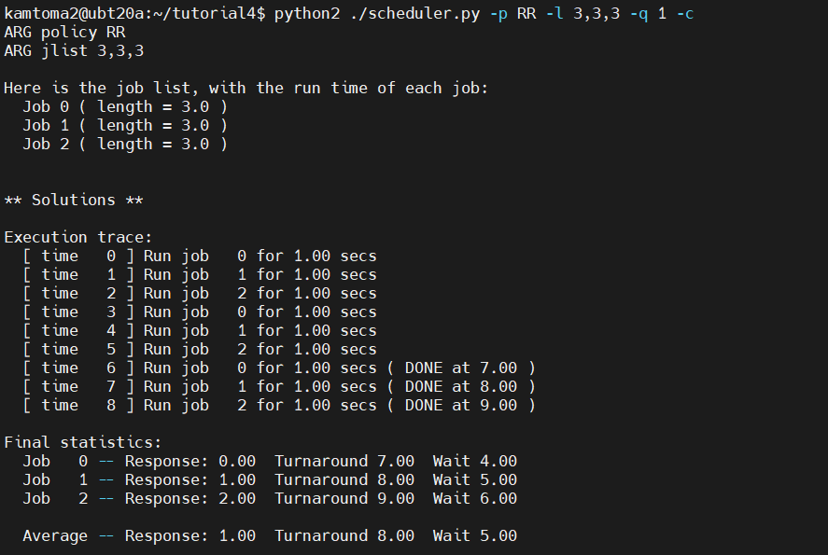

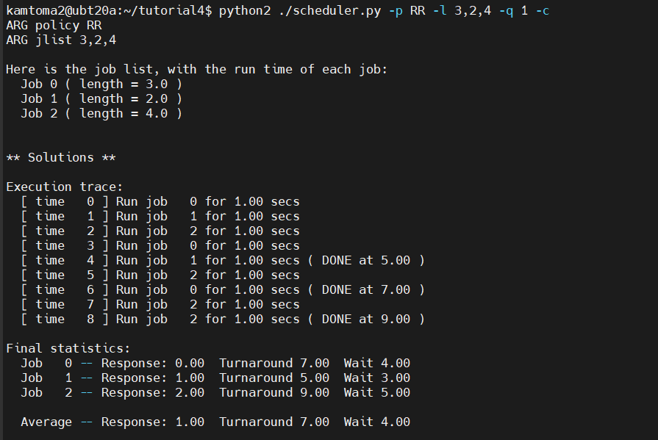

1. For what types of workloads does SJF deliver the same turnaround times as FIFO?

**Answer: If the order in which processes arrive at the ready queue is already sorted by job length (shortest to longest), then SJF and FIFO will produce the same turnaround times. This is because both algorithms will follow the same order. For example, -l 100,200,300 gives the same turnaround time for both SJF and FIFO.**

1. For what types of workloads and quantum lengths does SJF deliver the same response times as RR?

**Answer: If the quantum length in RR is set to be very long and is equal to or longer than the execution time of the shortest job in the workload, then RR can behave similarly to SJF. This is because, in this scenario, RR will complete each job in a single quantum, effectively prioritizing the shortest jobs just like SJF.**

1. What happens to response time with SJF as job lengths increase? Can you use the simulator to demonstrate the trend?

**Answer: Job lengths increase in SJF scheduling, the response time generally increases due to longer waiting times and potentially longer turnaround times. Shorter jobs that arrive later in the queue may need to wait longer before they get access to the CPU.**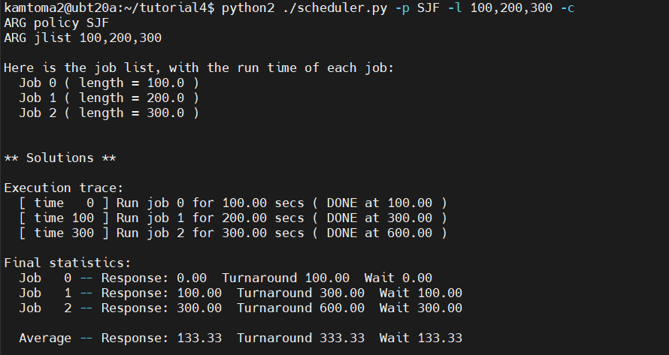

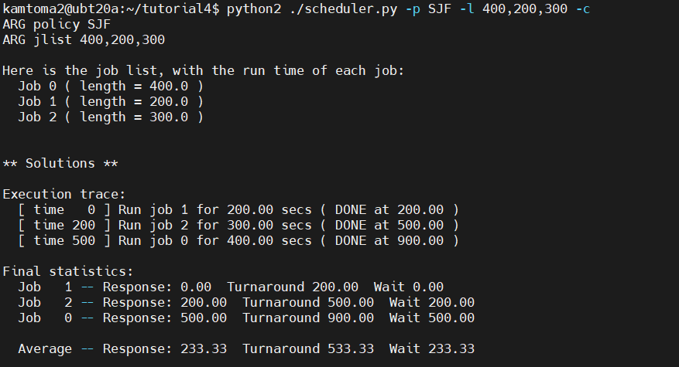

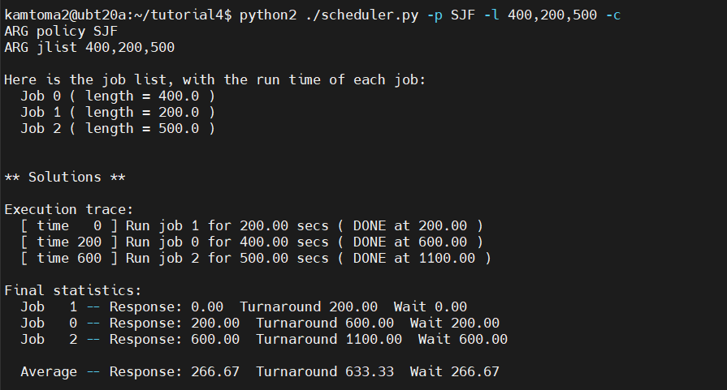

1. What happens to response time with RR as quantum lengths increase? Can you write an equation that gives the worst-case response time, given N jobs?

**Answer: As the quantum length (time slice) increases in RR scheduling, the response time typically increases. Longer quantum lengths mean that each process runs for a more extended period before being preempted, which can lead to increased waiting times for other processes in the ready queue. Worst-Case Response Time = (N - 1) * Quantum Length**

**The equation suggests that in the worst-case response time will also increase linearly, assuming that all jobs are of equal length. It is directly proportional to the number of jobs in the queue and the length of the time slice.**



